

Name: Sajjal Tariq
Roll No: 10011
Section: A
Submitted To: Sir Zohaib Khan

LAB NO. 2

Introduction to SQL, Data Definition Language (DDL) Commands, Data Types

Objectives | To practice and implement data definition language commands and constraints.

Instructions
- This is individual Lab work/task.
- Complete this lab work within lab timing.
- Discussion with peers is not allowed.
- You can consult any book, notes & Internet.
- Copy paste from Internet will give you negative marks.
- Lab work is divided into small tasks, complete all tasks sequentially.
- Show solution of each lab task to your Lab Instructor.
- Paste your solution (i.e. code) in given space under each task.
- Also make a zip/rar archive of all lab tasks and upload this file on LMS before leaving lab.
- In-Lab Exercises/Tasks

FACILITIES REQUIRED AND PROCEDURE
Facilities required to do the experiment
S.No. | Facilities Required | Quantity
1 | System | 1
2 | Operating System | Windows 10
3 | Front End | Java
4 | Back End | Oracle 11g, MySQL

Procedure for doing the experiment

Step | Details
1 | DDL COMMAND  It is used to communicate with database. DDL is used to:  Create an object  Alter the structure of an object  To drop the object created.
2 | The commands used are: Create, Alter, Drop, Truncate
3 | INTEGRITY CONSTRAINT  An integrity constraint is a mechanism used by oracle to prevent invalid data entry into the table. It has enforcing the rules for the columns in a table. The types of the integrity constraints are:  a) Domain Integrity  b) Entity Integrity  c) Referential Integrity
4 | a) Domain Integrity  This constraint sets a range and any violations that take place will prevent the user from performing the manipulation that caused the breach. It includes:  Not Null constraint:  While creating tables, by default the rows can have null value .the enforcement of not null constraint in a table ensure that the table contains values.  Principle of null values:  Setting null value is appropriate when the actual value is unknown, or when a value would not be meaningful.  A null value is not equivalent to a value of zero.  A null value will always evaluate to null in any expression.  When a column name is defined as not null, that column becomes a mandatory i.e., the user has to enter data into it.  Not null Integrity constraint cannot be defined using the alter table command when the table contain rows.

SQL COMMANDS

Create Table
It is used to create a table
Syntax: Create table tablename (column_name1 data_ type constraints, column_name2 data_ type constraints ...)
Example:

CREATE TABLE dept (
deptno NUMBER(3) PRIMARY KEY,
dname VARCHAR2(20)
);

CREATE TABLE emp (
empNo NUMBER(5),
ename VARCHAR2(15),
job CHAR(10),
deptno NUMBER(3),
CONSTRAINT un UNIQUE (empNo),
CONSTRAINT fkey2 FOREIGN KEY (deptno)
REFERENCES dept(deptno)
);

create table student (sname varchar2(20) not null,
rollno number(10) not null,
dob date not null);
Rules:
1. Oracle reserved words cannot be used.
2. Underscore, numerals, letters are allowed but not blank space.
3. Maximum length for the table name is 30 characters.
4. 2 different tables should not have same name.
5. We should specify a unique column name.
6. We should specify proper data type along with width.
7. We can include “not null” condition when needed. By default it is „null‟.

Alter Table
Alter command is used to:
1. Add a new column.
2. Modify the existing column definition.
3. To include or drop integrity constraint.
Syntax: alter table tablename add/modify (attribute datatype(size));
Example:
1. Alter table emp add (phone_no char (20));
2. Alter table emp modify(phone_no number (10));
3. ALTER TABLE EMP ADD CONSTRAINT Pkey1 PRIMARY KEY (EmpNo);
Code for altering the table emp.
ALTER TABLE emp
ADD phone_no CHAR(20);

Drop Table
It will delete the table structure provided the table should be empty.
Example: drop table prog20; Here prog20 is table name

Truncate Table
If there is no further use of records stored in a table and the structure has to be retained then the records alone can be deleted.
Syntax: TRUNCATE TABLE <TABLE NAME>;
Example: Truncate table stud;

Describe
This is used to view the structure of the table.
Example: desc emp;
Name Null? Type --------------------------------- --------
EmpNo NOT NULL number(5)
EName VarChar(15)
Job NOT NULL Char(10)
DeptNo NOT NULL number(3)
PHONE_NO number (10)

Domain Integrity
Example: Create table cust(custid number(6) not null, name char(10));
Alter table customer modify (name not null);
Exercise 1:
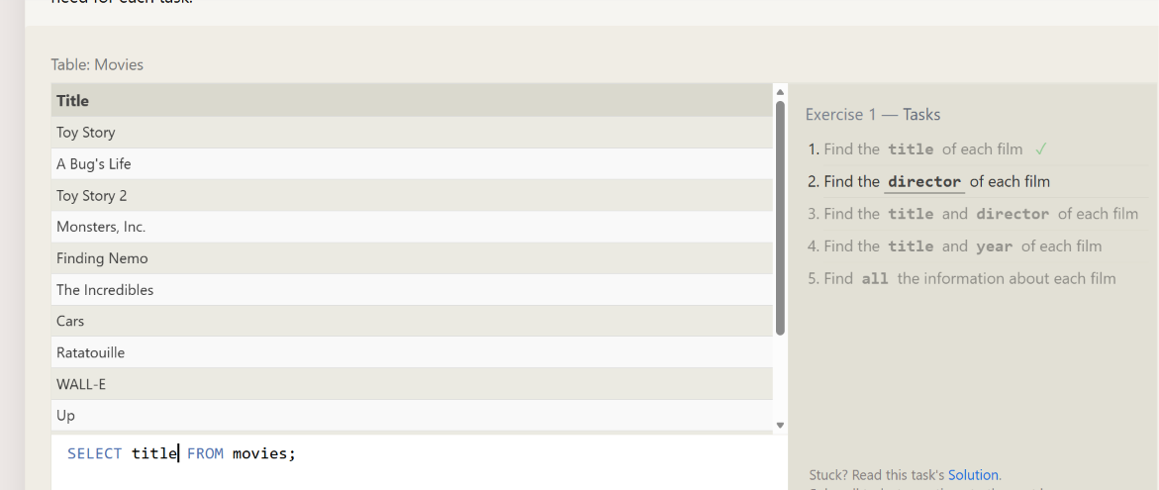
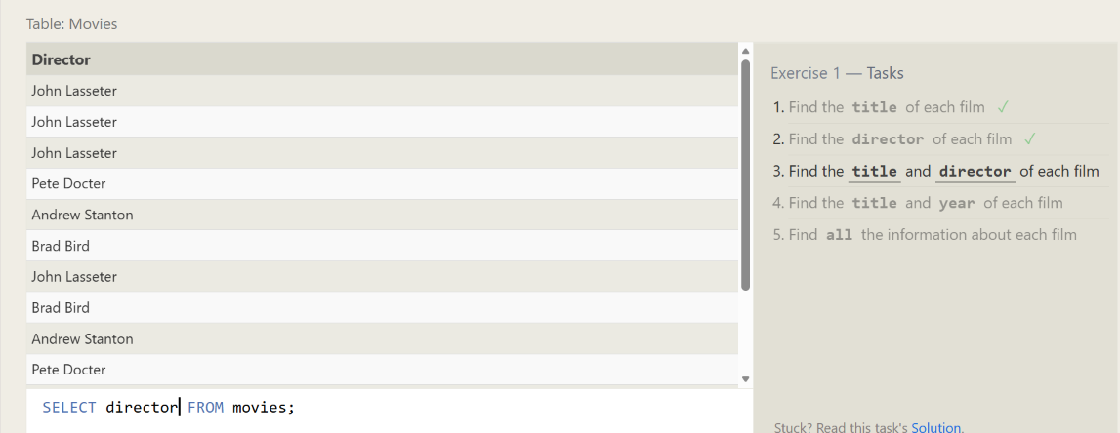
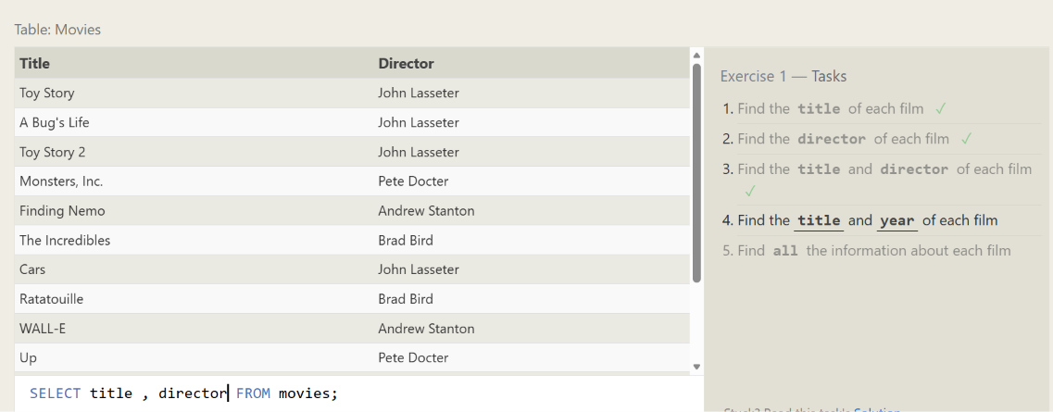
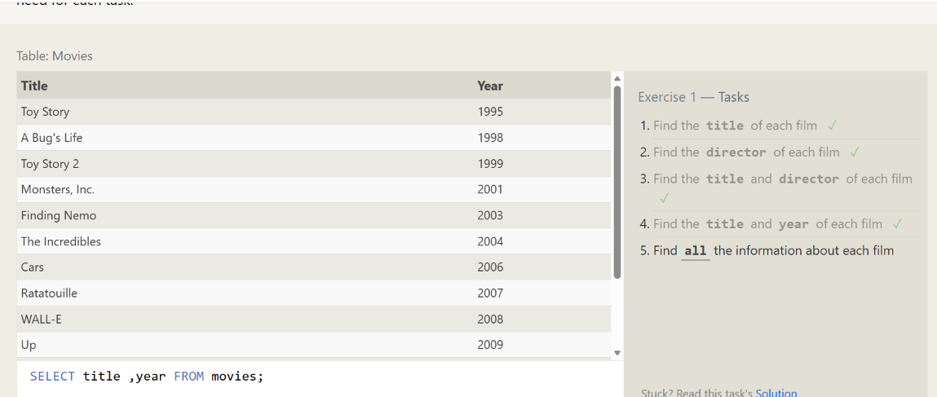
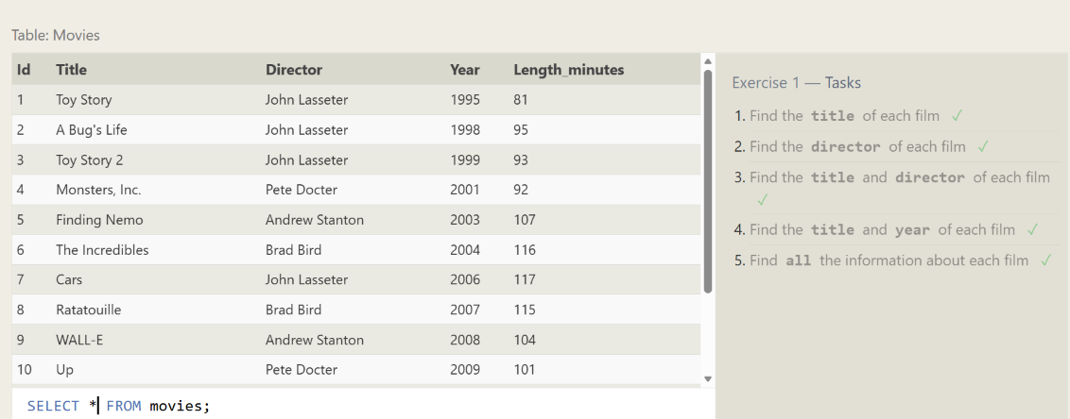
Exercise 2: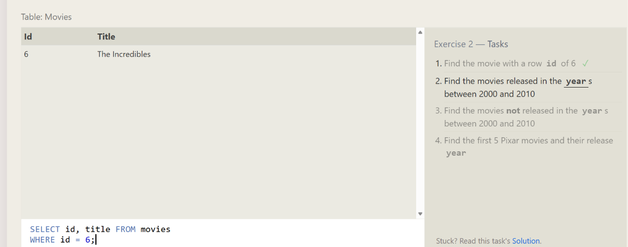
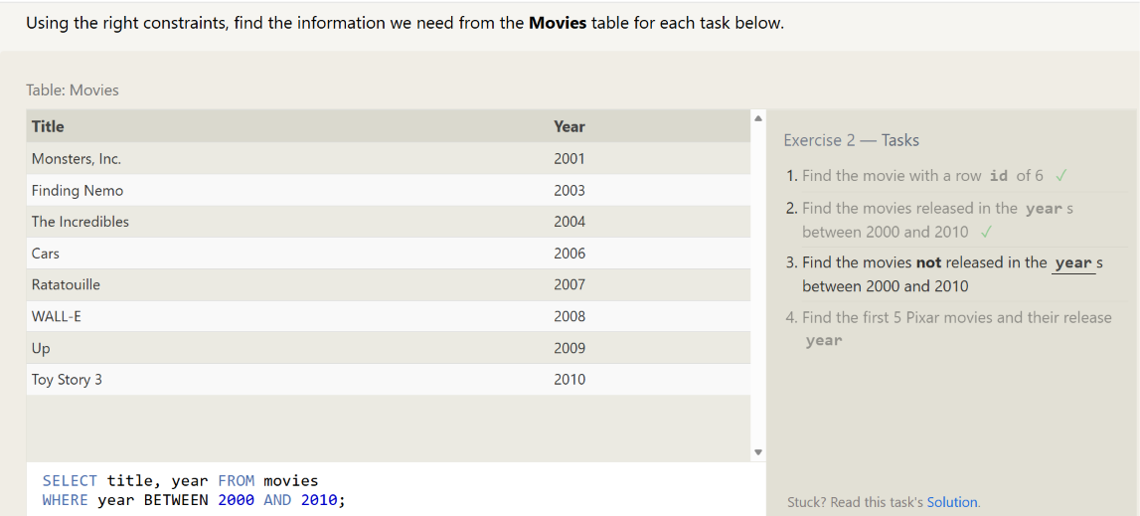
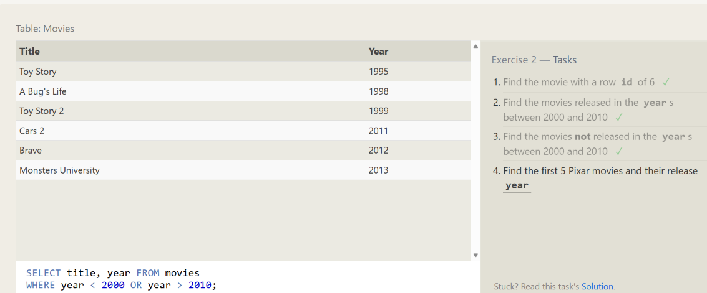
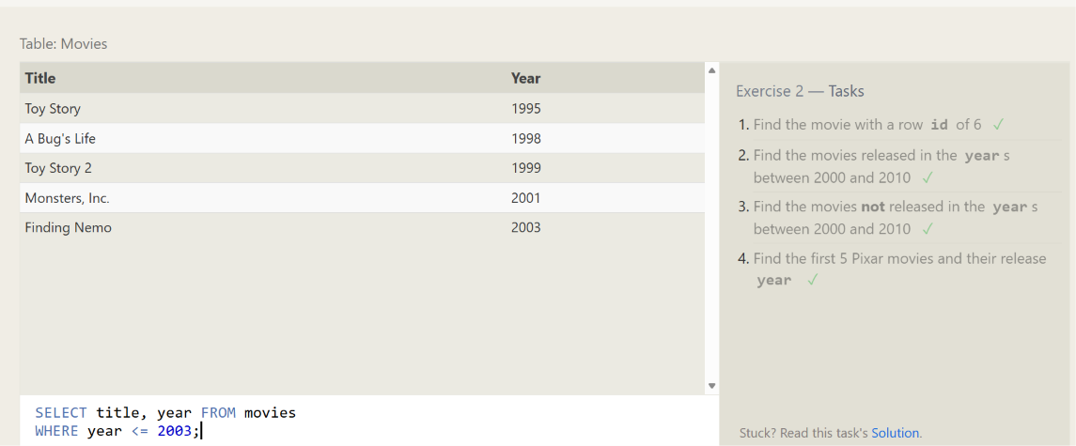

Exercise 3: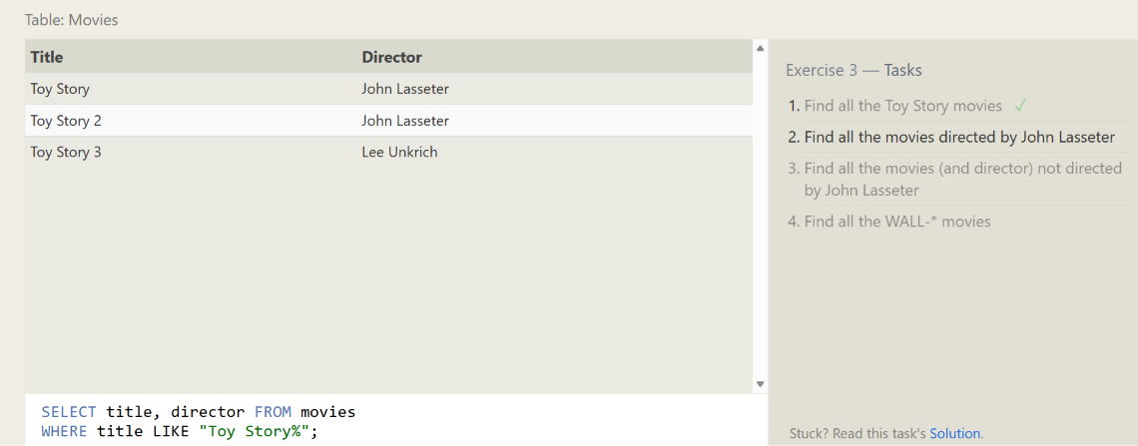
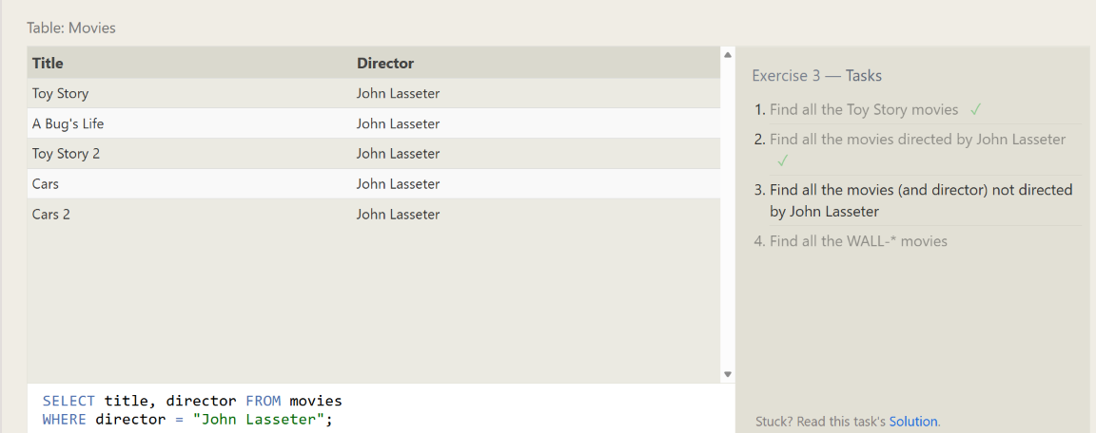
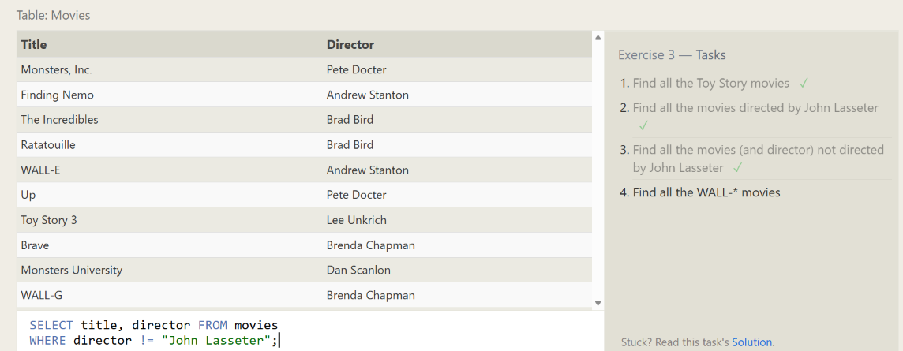

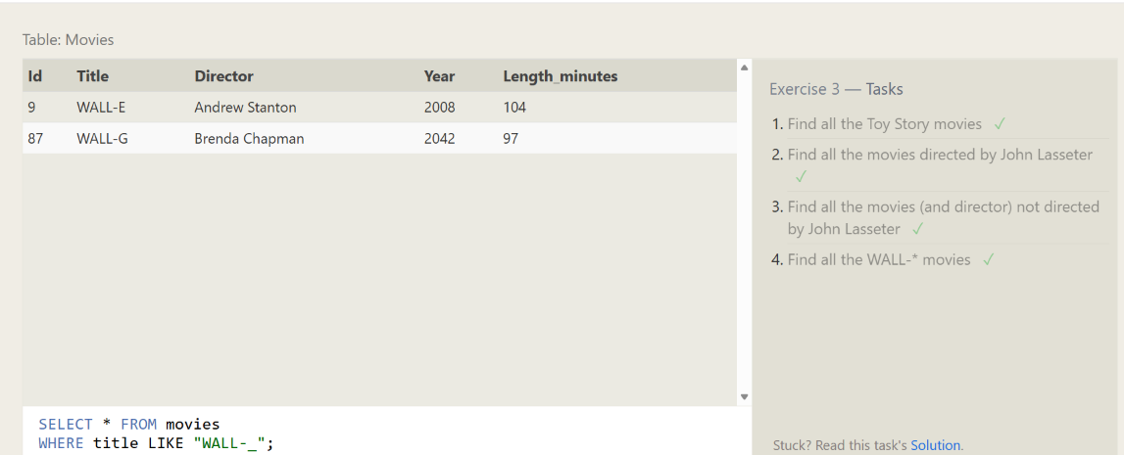
Exercise 4
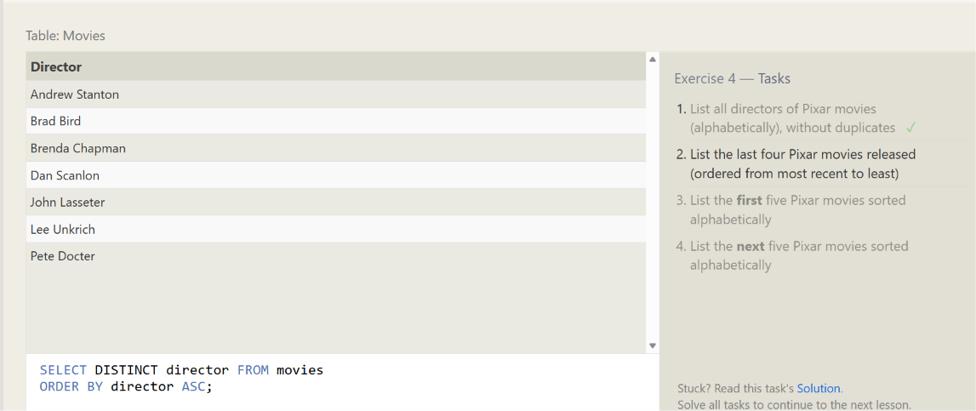
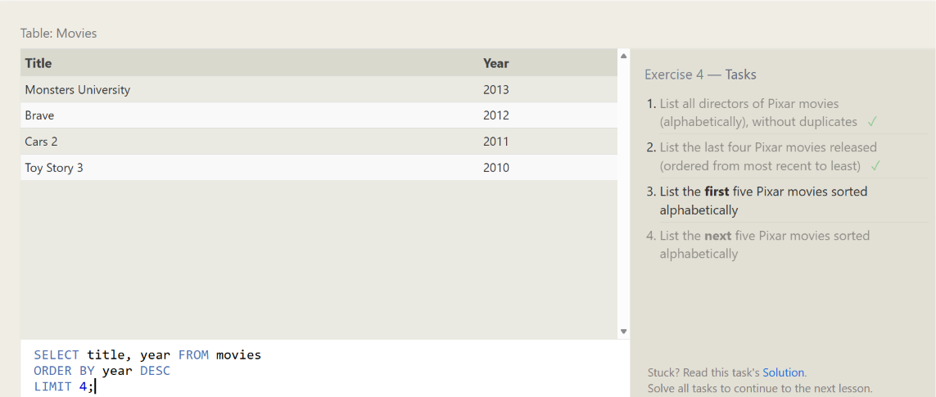
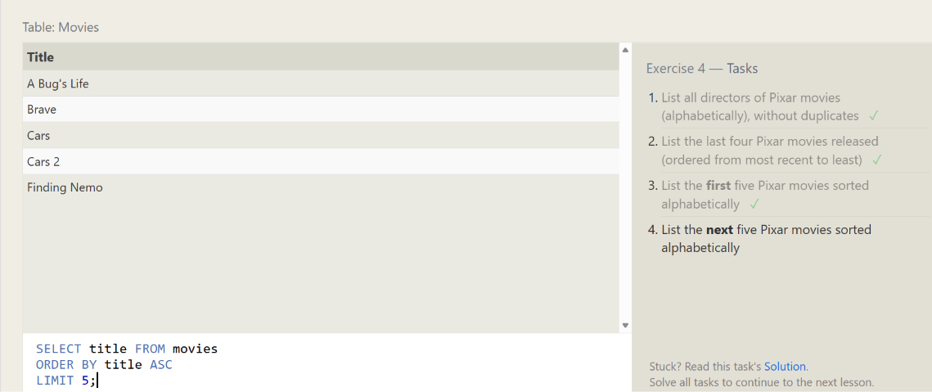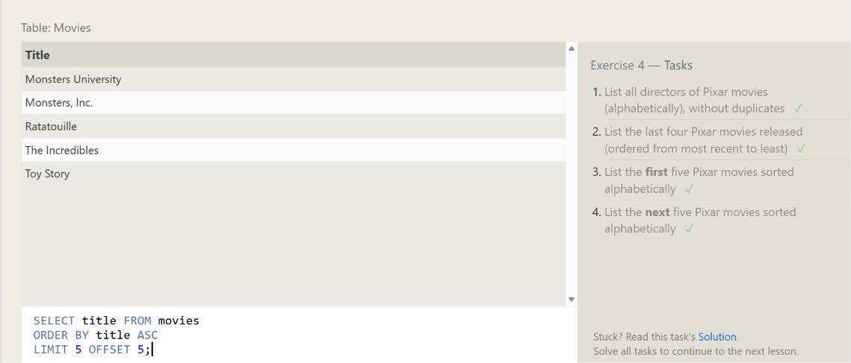

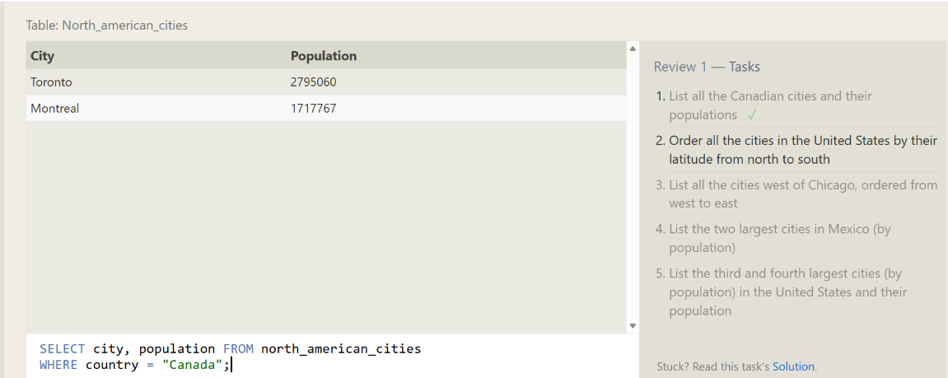
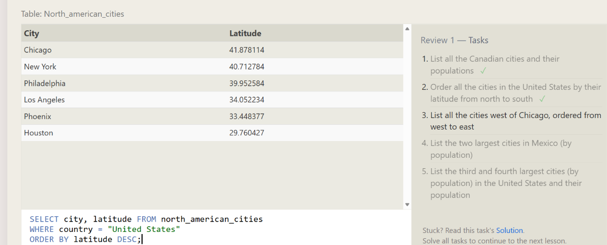
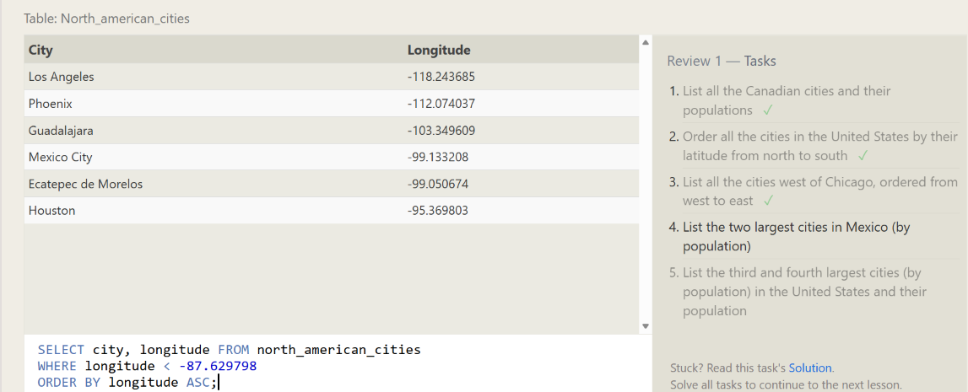

Tasks

Q1. Create a table called EMP with the following structure.

Name Type
---------- ----------------------
EMPNO NUMBER (6)
ENAME VARCHAR2 (20)
JOB VARCHAR2 (10)
DEPTNO NUMBER (3)
SAL NUMBER (7, 2)
Allow NULL for all columns except ename and job.
Answer:
1. Understand create table syntax.
2. Use the create table syntax to create the said tables.
3. Create primary key constraint for each table as you understand from logical table structure.

SQL> create table emp (
empno number(6),
ename varchar2(20) not null,
job varchar2(10) not null,
deptno number(3),
sal number(7,2));
Table created.
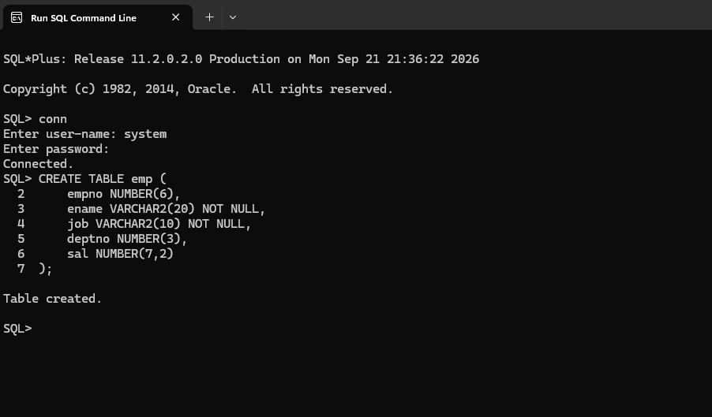

Q2: Add a column experience to the emp table. Experience numeric null allowed.

Answer:
1. Learn alter table syntax.
2. Define the new column and its data type.
3. Use the alter table syntax.
SQL> alter table emp add (experience number(2));
Table altered.
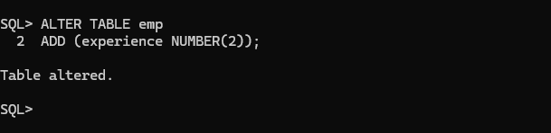

Q3: Modify the column width of the job field of emp table.
Answer:
1. Use the alter table syntax.
2. Modify the column width and its data type.
SQL> alter table emp modify (job varchar2 (12));
Table altered.
SQL> alter table emp modify (job varchar2 (13));
Table altered.
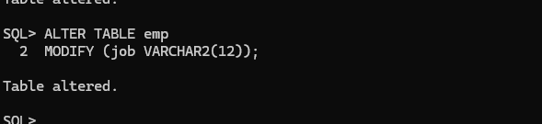

Q4: Create department table with the following structure.
Name Type
------------ ---------------------
DEPTNO NUMBER (2)
DNAME VARCHAR2 (10)
LOC VARCHAR2 (10)
Deptno as the primarykey
Answer:
1. Understand create table syntax.
2. Decide the name of the table.
3. Decide the name of each column and its data type.
4. Use the create table syntax to create the said tables.
5. Create primary key constraint for each table as understand from logical table structure.
SQL> create table department (
deptno number(2),
dname varchar2(10),
loc varchar2(10),
constraint dept_deptno_pk primary key (deptno));
Table created.
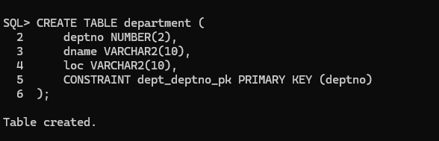

Q5. Create a table called staff with the following structure.

Name Type
---------- ----------------------
EMPNO NUMBER(6)
ENAME VARCHAR2(20)
JOB VARCHAR2(10)
DEPTNO NUMBER(3)
SAL NUMBER(7,2)
Deptno as foreign key

Answer:
1. Understand create table syntax.
2. Use the create table syntax to create the said tables.
3. Create foreign key constraint for each table as you understand from logical table structure.

SQL> create table staff (
empno number(6),
ename varchar2(20),
job varchar2(10),
sal number (7,2)
deptno number(3),
constraint staff_deptno_fk foreign key (deptno) references dept(deptno);

Table created.
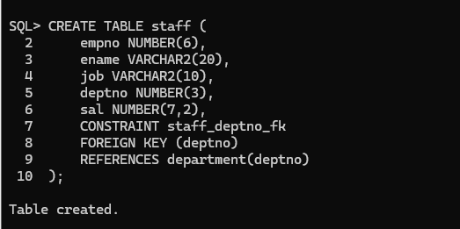

QUESTIONS AND ANSWERS

Define the terms
DDL:
Data base schema is specified by a set of definitions expressed by a special language called a data definition language.

What are the categories of SQL command?
SQL commands are divided in to the following categories:
Data Delimitation language
Data manipulation language
Data control language
Transaction Control Language

What is integrity constraint?
An integrity constraint is a mechanism used by oracle to prevent invalid data entry into the table. It has enforcing the rules for the columns in a table.
List the types of constraint.
Domain Integrity
Entity Integrity
Referential Integrity
Primary Key Constraint
A primary key avoids duplication of rows and does not allow null values. It can be defined on one or more columns in a table and is used to uniquely identify each row in a table. These values should never be changed and should never be null.
Referential Integrity
It enforces relationship between tables. To establish parent-child relationship between 2 tables having a common column definition, we make use of this constraint. To implement this, we should define the column in the parent table as primary key and same column in the child table as foreign key referring to the corresponding parent entry.

Extra Tasks

Q1. To delete an employee with id 100 from the EMP table.

Code:
CREATE TABLE emp (
empno number(6),
ename varchar2(20) not null,
job varchar2(10) not null,
deptno number(3),
sal number(7,2));
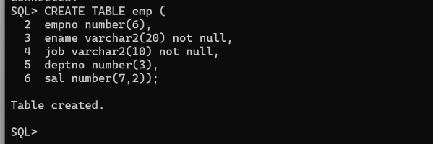

Q2. To delete all the rows from the EMP table.

Code:
INSERT INTO emp VALUES (100, 'Ali', 'Manager', 10, 50000);
INSERT INTO emp VALUES (101, 'Sara', 'Clerk', 20, 15000);
COMMIT;
SELECT * FROM emp;
DELETE FROM emp;
COMMIT;

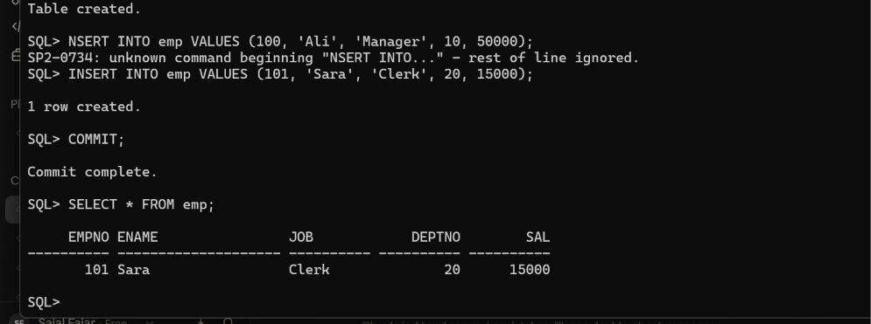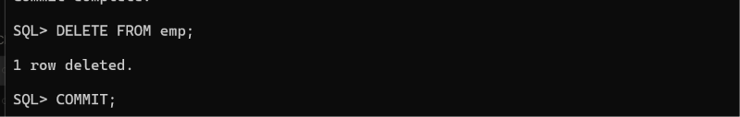

Q3. To delete all the rows from employee table using Turncate query.

Code:
TRUNCATE TABLE emp;

Q4. To drop the table EMP.

Code:

INSERT INTO emp VALUES (100, 'Ali', 'Manager', 10, 50000);
INSERT INTO emp VALUES (101, 'Sara', 'Clerk', 20, 8000);
COMMIT;
DELETE FROM emp WHERE sal > 10000;
COMMIT;
DROP TABLE emp;
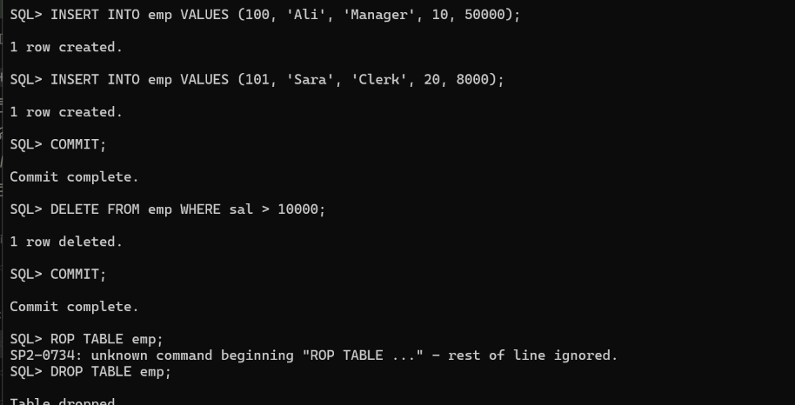

Q5. To delete all rows from the EMP table where Salary is greater than 10000.

Paste code and screenshot here

